SMART SIGNALLING SYSTEM

Dr. A. Vaideghy (1), Srinivasan R (2), Aathisivan K (3)
¹Assistant Professor, Department of Computer Technology, PSG College of Arts & Science, Coimbatore, Tamil Nadu, India. vaideghy@gmail.com
²Student, Department of Computer Technology, PSG College of Arts & Science, Coimbatore, Tamil Nadu, India.
22bct056@psgcas.ac.in
³Student, Department of Computer Technology, PSG College of Arts & Science, Coimbatore, Tamil Nadu, India.
22bct001@psgcas.ac.in

Abstract— An IoT-based traffic management system can dynamically adjust traffic light timings based on real-time traffic data, improving traffic flow and reducing congestion. Expected. The Problem statement is to develop a smart, IoT-based traffic management system that can monitor traffic conditions in real-time and adapt traffic light timings accordingly. The system should be capable of handling heavy traffic from multiple directions and optimizing traffic flow to minimize delays and improve overall efficiency.
Keywords—IoT, Arduino, Signal, Sensors, Vehicles

Introduction
My topic smart traffic signalling system is an IoT based Automated system where the movement of vehicle is based upon the density of the vehicles in that particular lane. This topic was inspired from the Smart India Hackathon website (SIH 1607) A smart AI based solution for traffic management on routes with heavy traffic from different directions, with real-time monitoring and adaptation of traffic light timings.
Urban areas often face significant traffic congestion, especially at intersections where multiple routes converge. Traditional traffic management systems rely on pre-set traffic light timings, which may not adapt well to fluctuating traffic conditions. This can lead to increased waiting times, fuel consumption, and emissions. An IoT-based traffic management system can dynamically adjust traffic light timings based on real-time traffic data, improving traffic flow and reducing congestion. Expected. The Problem statement is to develop a smart, IoT-based traffic management system that can monitor traffic conditions in real-time and adapt traffic light timings accordingly. The system should be capable of handling heavy traffic from multiple directions and optimizing traffic flow to minimize delays and improve overall efficiency.
For developing an prototype for this method there are multiple ways like using camera with python packages that will calculate the total length of the traffic and send it to the python and it will execute the signal and another way is using IoT by placing ultrasonic sensor or proximity sensor. In my project I had used ultrasonic sensor. In my module. For processing the data I had used the Arduino MEGA 2680 and Arduino nano board. One of my key feature of my prototype is RFID tag.
RFID tag is an wireless device that uses radio waves for transmitting data. RFID tags are provided to high priority vehicles like Ambulance and VIP vehicles so when it approaches in a direction automatically that lane will turn green.

MODULE DESCRIPTION

Software description
Arduino board is used to load the program and perform the logic of the overall module. For the programming part Arduino IDE is used it is an open source software that uses C programming logic. The USB port present in the Arduino board will load the program once the program is loaded it will perform the logic according to the code.

Hardware description
2 Types of Arduino boards were used in the module the Arduino NANO and Arduino MEGA 2560 and Arduino NANO. Arduino mega is used to run the complex modules and code it uses SRAM memory space and NANO is used to run RFID tag part. Ultrasonic sensors are places in all direction corresponding distances to measure the density of the vehicle. RFID tags and scanners are placed to sense the emergency vehicle approaching the signal. Signal modules are placed in each direction as traffic signal for automatic change of signal. Additionally jumper wires and resistors are placed for connection of Arduino board LED,s
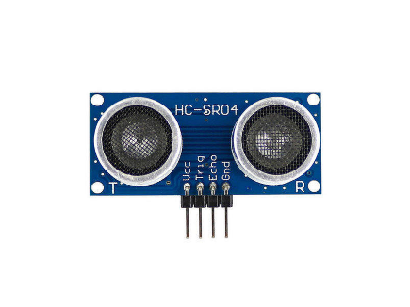
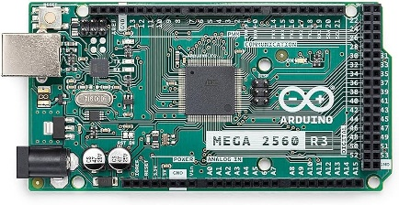
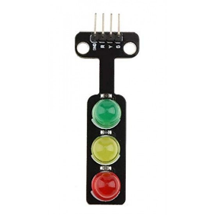

WORKING DESCRIPTION OF MODULE
Ultrasonic sensors are placed in the all directions of the signal in sequential distances to measure the density and distances of vehicles in each direction the ultrasonic sensor will send the input signal to the Arduino MEGA board which will collect the signal and send that signal to the traffic signal module. Resistors of 220 ohms are placed in the ultrasonic sensors to avoid overflow of data. The Arduino MEGA board is loaded with the logic program for the automated signaling using Arduino IDE with the help of USB. It will act according to the program and sends the output data to the Traffic signal module and it will give signal according to the density of the vehicle. RFID tags are placed in the ambulance and RFID sensor will be placed in each direction to sense the ambulance. Once any ambulance approaches the signal the RFID emit radio wave and the sensor will get the data from the wave and sends it to the Arduino NANO board. The NANO board also comes in with preloaded program using Arduino IDE for the logic of RFID tags. These all devices are interconnected with the help of jumper wires and breadboard. The jumper wires used are Male-Male, Male-Female, Female-Female. And an external power supply is connected to the Arduino MEGA board. The circuit diagram illustrates the model
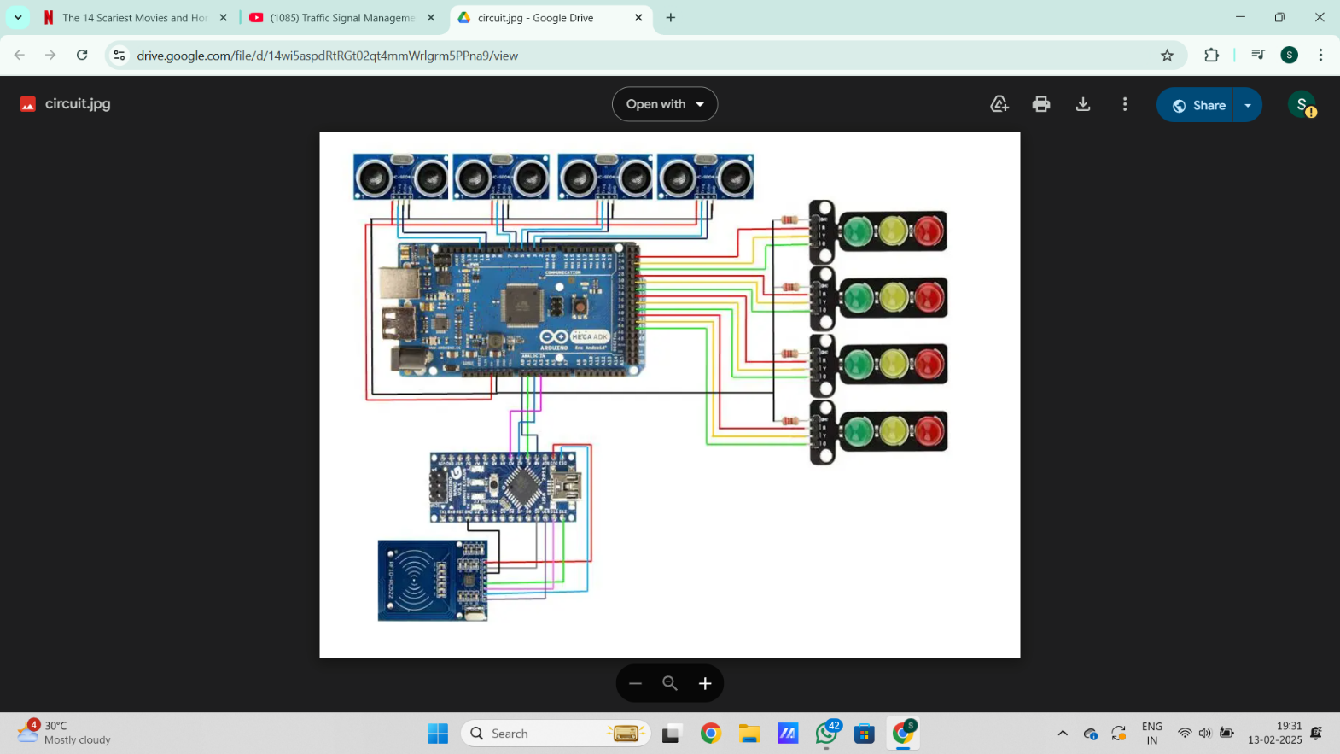

Identify applicable funding agency here. If none, delete this text box.

Problems in the existing system
In Indian cities the existing system has manual timings of the signals so if any particular direction experiences more traffic flow vehicles will be signaled manually and the role of the traffic police will be difficult in the peak hours and if any small error can cause more delays which result in heavy traffic. To avoid over traffic, reduce pollution and man power my automated smart signalling system can be used to solve these problems.
The new system can be implemented in trailed manner in some major traffic signals and analyse the results by getting the feedback from the motorists and traffic police and by getting their suggestions we can further implement the technology in further areas and change some modules based upon the feedback from the users.
RFID tag will be provided to all ambulances in the city and some special vehicles for the special occasions like Prime Ministers or Chief Ministers. During the manual signal any ambulance approaches an direction and that particular direction is green it is fine if that direction is red then it will be difficult for the traffic police that he should turn that direction green and clear the traffic to give way to ambulance that consumes time and each minute is crucial for an ambulance to save lives. In my system all ambulances will be given RFID tag like Fast tag and if any ambulance approaches an direction that RFID tag will emit radio wave and the sensor will scan the tag and automatically it will send the signal to the Traffic signal module and that lane will turn green.

IMPLEMENTATION PART
I had travelled across Coimbatore and found some areas where I can implement my project test those areas are
Kalapatty signal
Gandhipuram signal
Goods shed road signal
Salem Kochi highway signal
Brooke fields signal etc
These are the places where we can implement this concept for a trail basis and from the user feedback we can further implement this in other areas also the current existing system of U-Turn is not convenient for all especially for senior citizens and ladies they find difficult to turn their vehicle and change lane and if any large vehicle like bus or lorry makes a turn the other back vehicles should wait until the lorry makes a turn so instead if we apply this system and if it found to be reliable and user friendly we can implement it in all places.

CONCLUSION
Automated signaling system will be efficient, Energy saving and adaptable to the modern world as it has more features and less prone to error and reduce the man power and less prone to accidents. It can be implemented in selective areas on a trail basis and after getting feedback from the customer we can improve and implement in all areas. The adaptation requires extensive research work about the traffic flow length and width of the roads, nearby locations and peak hours which can be used as an reference to develop an prototype for that particular area. The model need not be the same to all the places it varies according to the area, size of the road and other factors too. This is a proposed system which can be implemented using various techniques and it can provide better results and can be adapted easily to current needs.

References
[1] SIH problem statement for reference https://www.sih.gov.in/sih2024PS

[2] Software link https://www.arduino.cc/en/software

[3] Case study https://intellias.com/smart-traffic-signals/

[4] Research paper for automated traffic system https://www.researchgate.net/publication330890240_Smart_Traffic_Light_System_by_Using_Artificial_Intelligence

[5] https://ieeexplore.ieee.org/document/10126180/ IEEE paper for Reference

[6] Research paper based on IoT concept https://ijtrs.com/uploaded_paper/SENSOR%20BASED%20SMART%20TRAFFIC.pdf

